1. 
2. 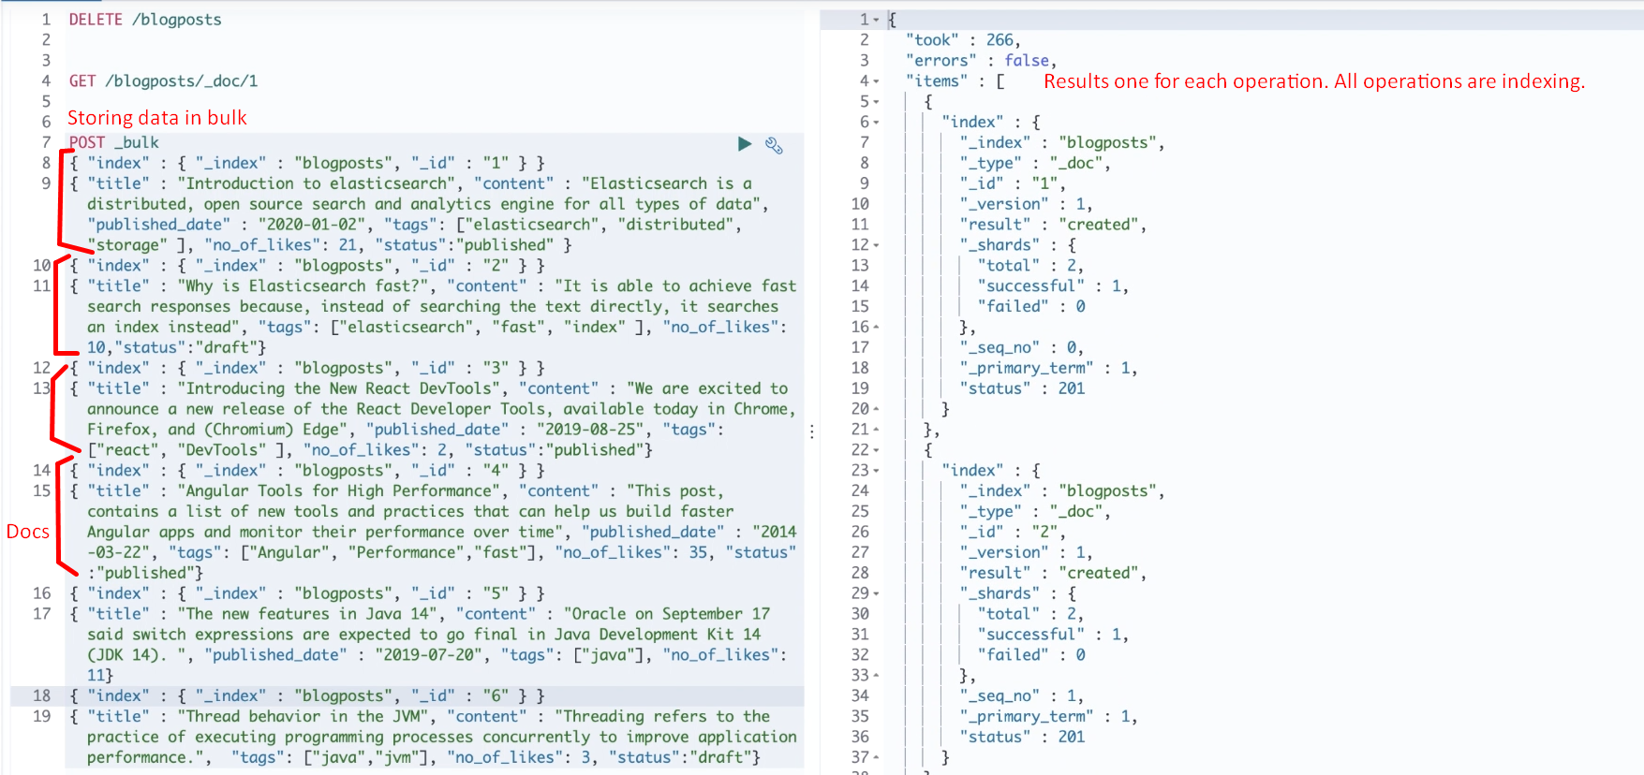
3. d
   1. **timed_out** 🡺 Default is 60 seconds.
   2. _shard 🡺 Physical Representation of an index.
      1. As Elasticsearch is distributed search engine. So, Elasticsearch is usually split into the elements known as shards.
      2. Elasticsearch automatically manages the shards and rebalance it. So no need to worry.
   3. **hits**: Total # of documents matching the search criteria.
   4. _score:
      1. Most important attribute in response.
      2. Contains the measurement of how relevant that document is for the given search criteria.
      3. The docs in the result set are sorted as per _score.
4. 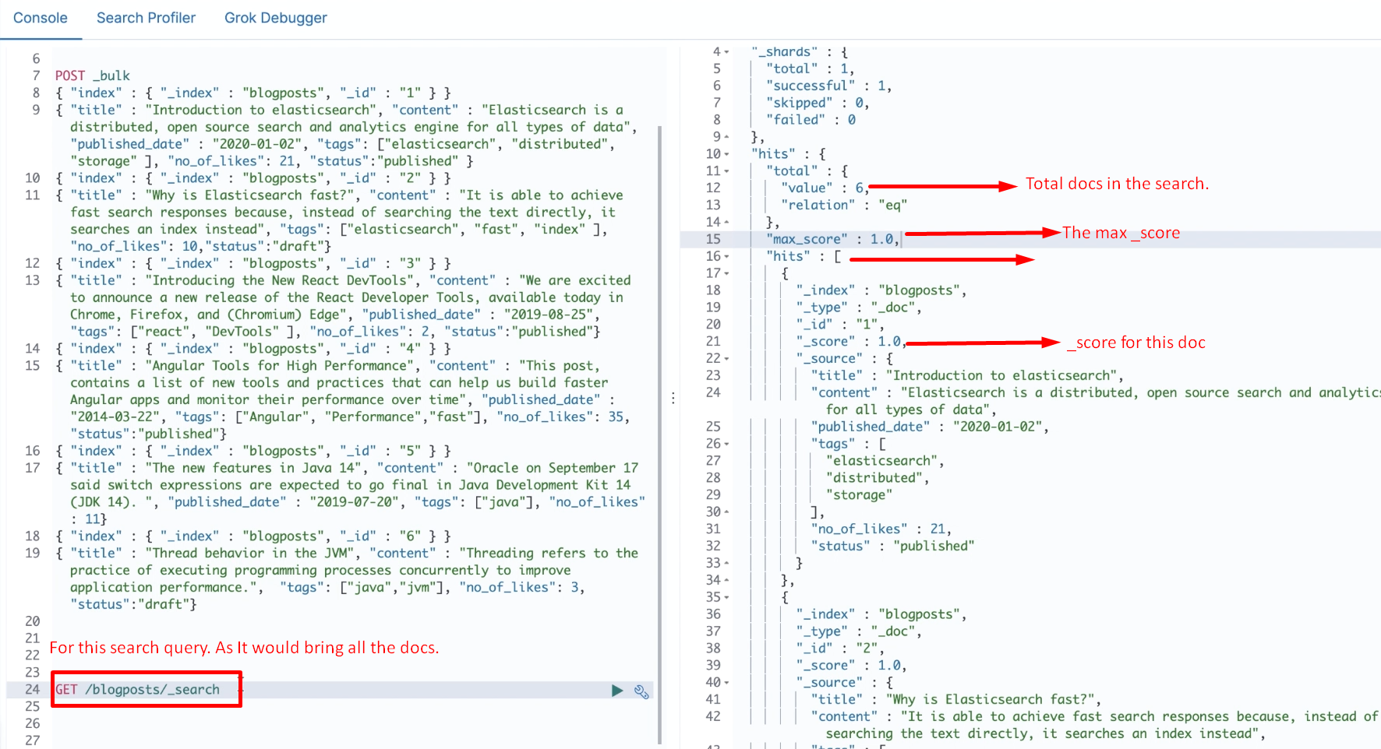
5. **To search for a term in any field**:
   1. 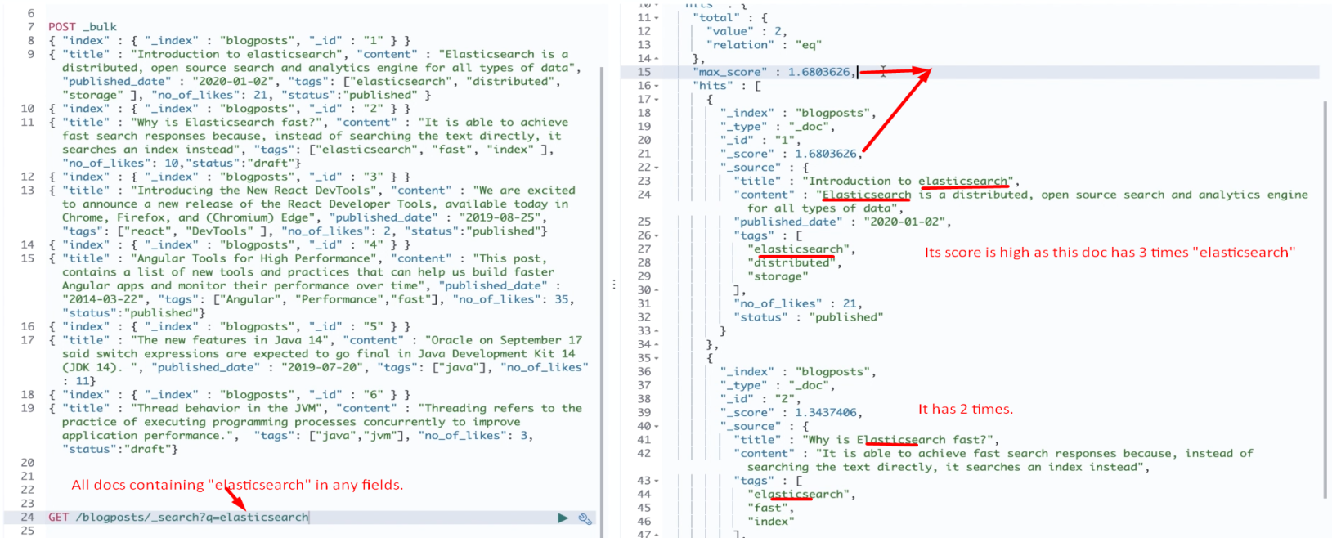
6. **To search into a particular field**:  
   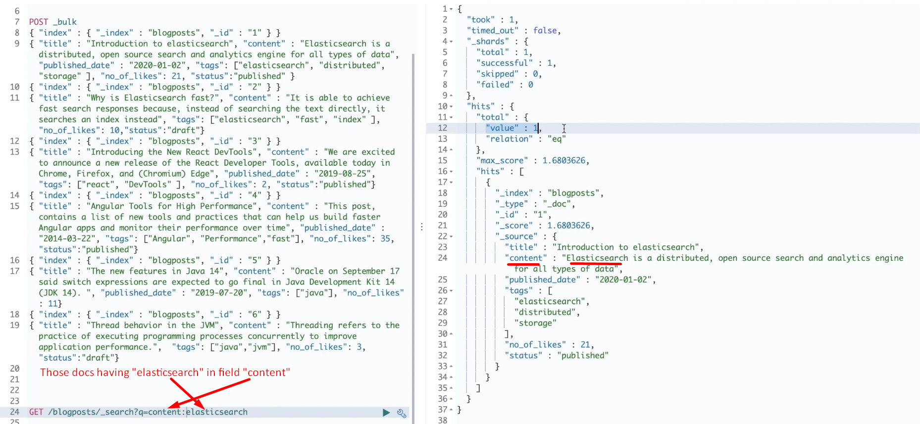
7. 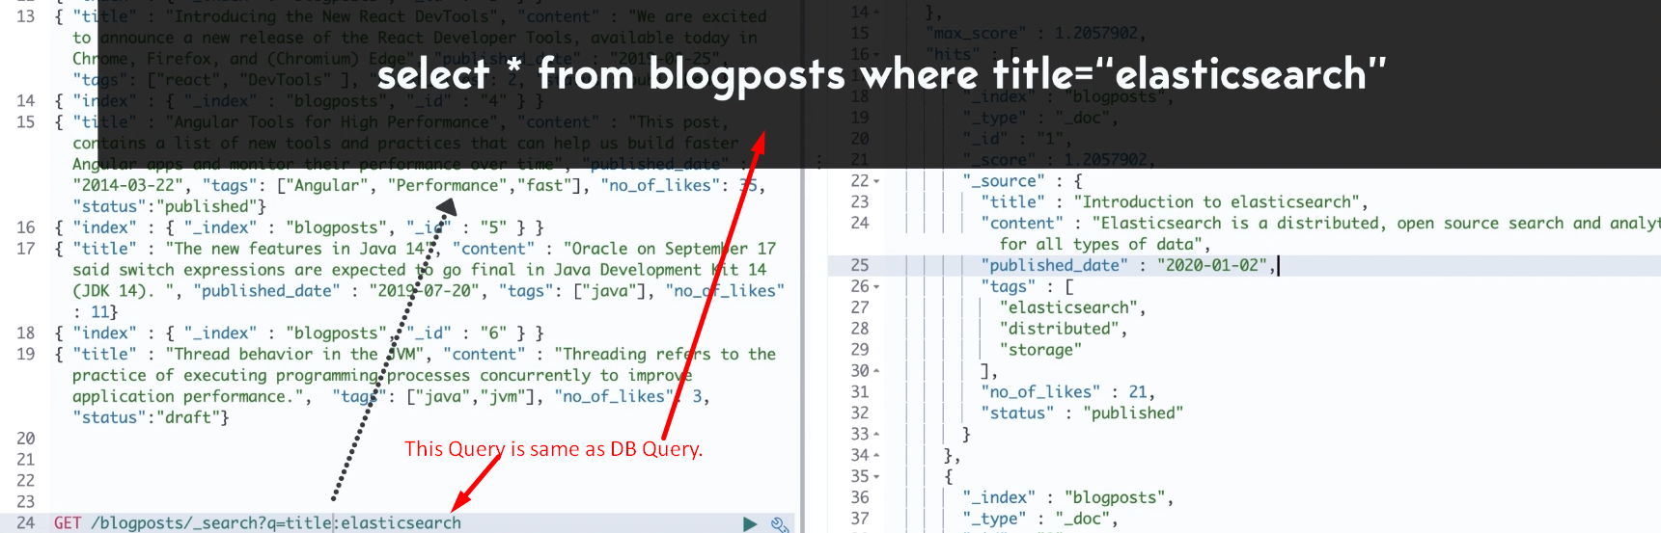
8. Elasticsearch uses scoring model 🡺 TF-IDF.
9. **TF-IDF**:
   1. **T**erm **F**requency-**I**nverse-**D**ocument-**F**requency
   2. We will talk about this later on.
10. 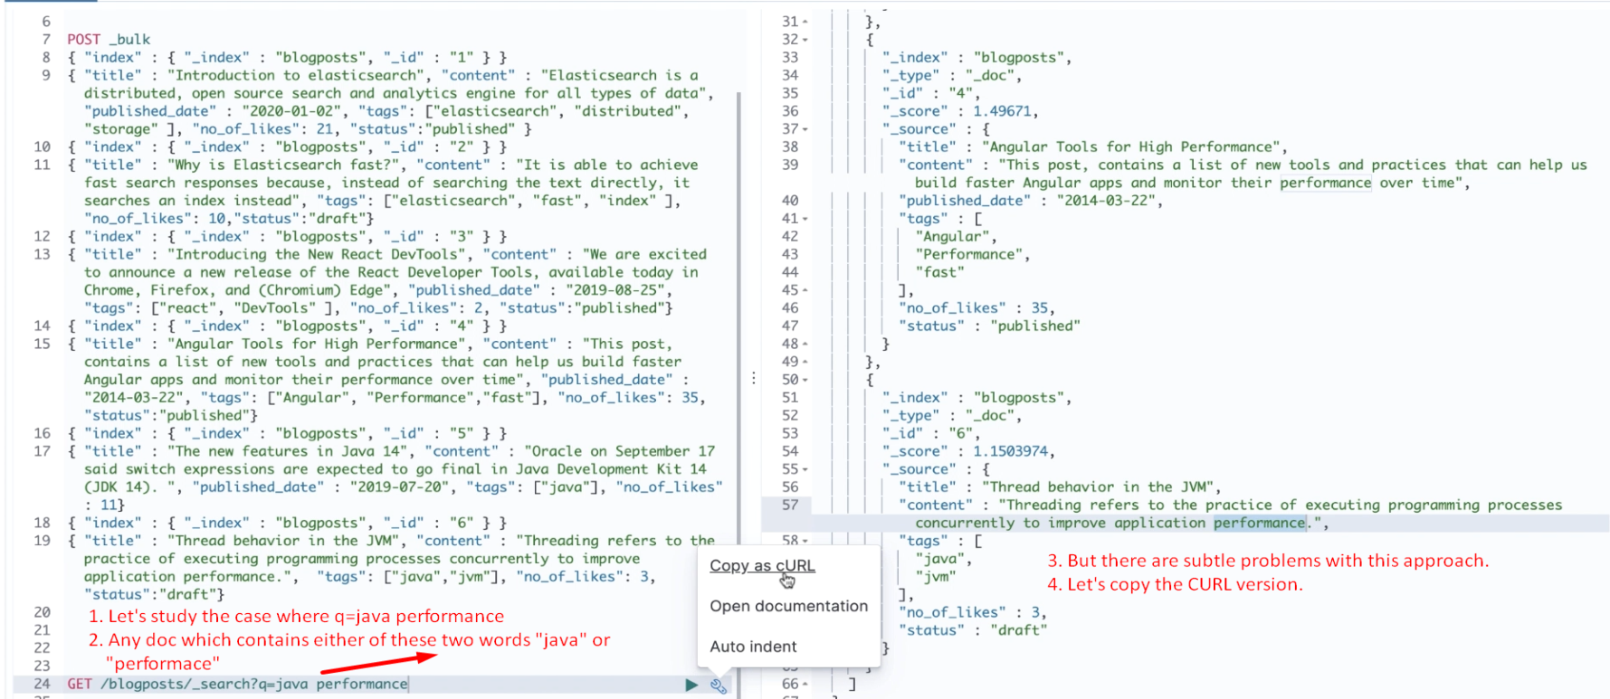
11. 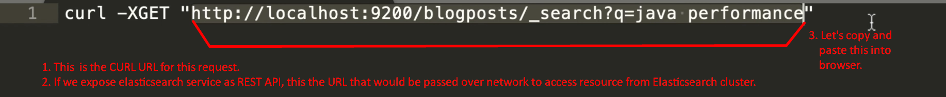
12. **Problems with this syntax**: 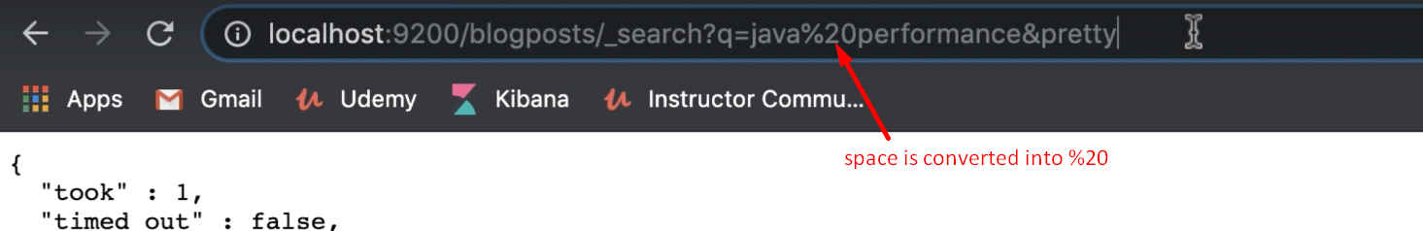
    1. It’s difficult to trace any misspelled characters such as space, comma, hypen as they are encoded in URL.
    2. Data is exposed.
13. **Solution**:  
    
    1. **Query DSL:**
       1. Allows us to build very complicated queries.
       2. It is like request body search API.
          1. Here we will send query in the request body.
          2. In production, we rely on the full featured request body search API.
14. 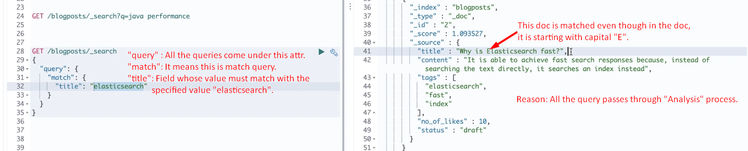
15. 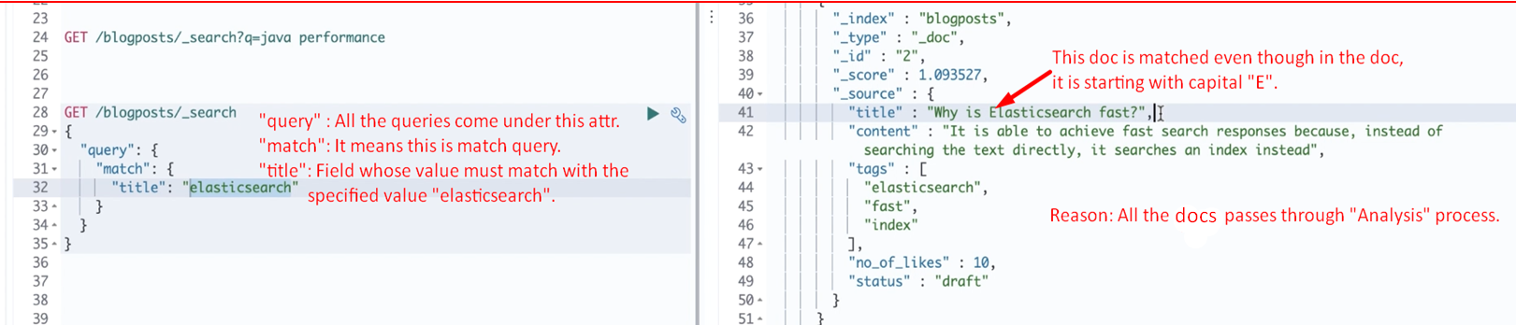
16. 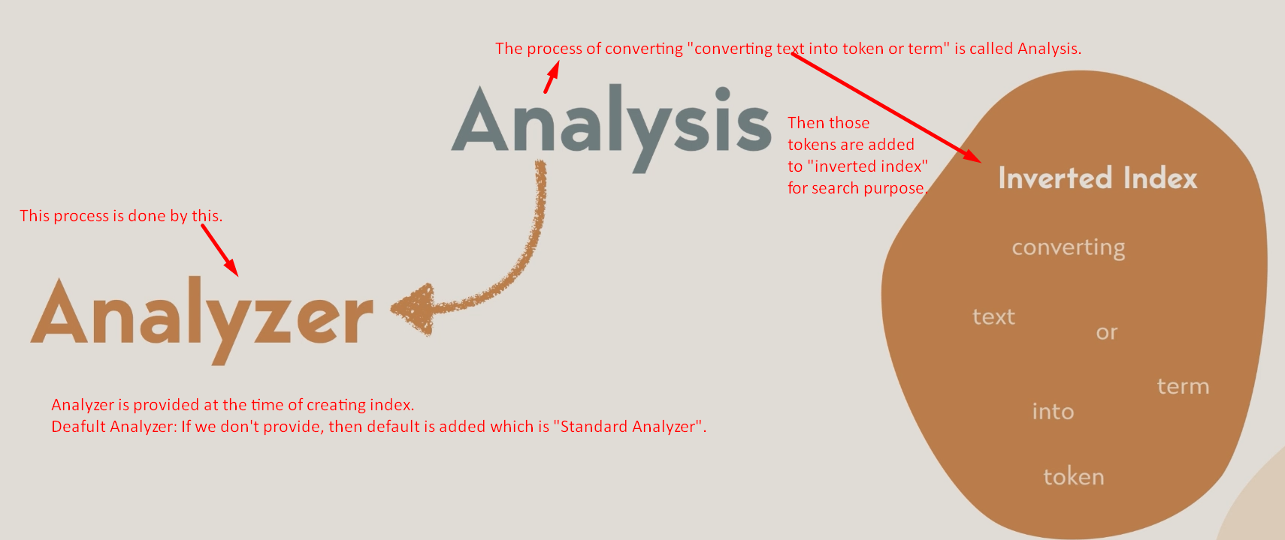
17. 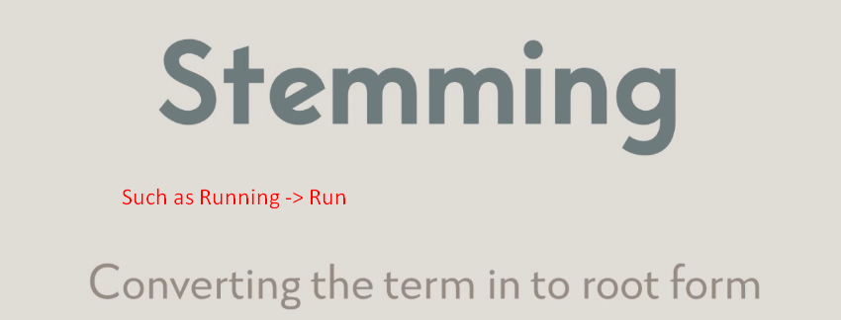
18. 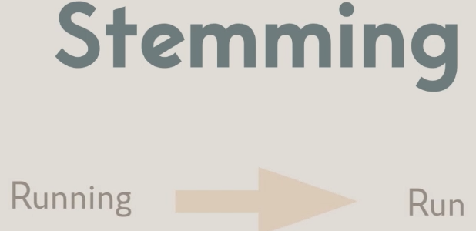
19. 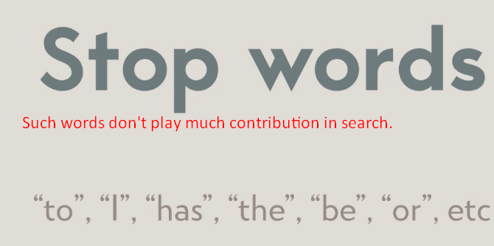
20. 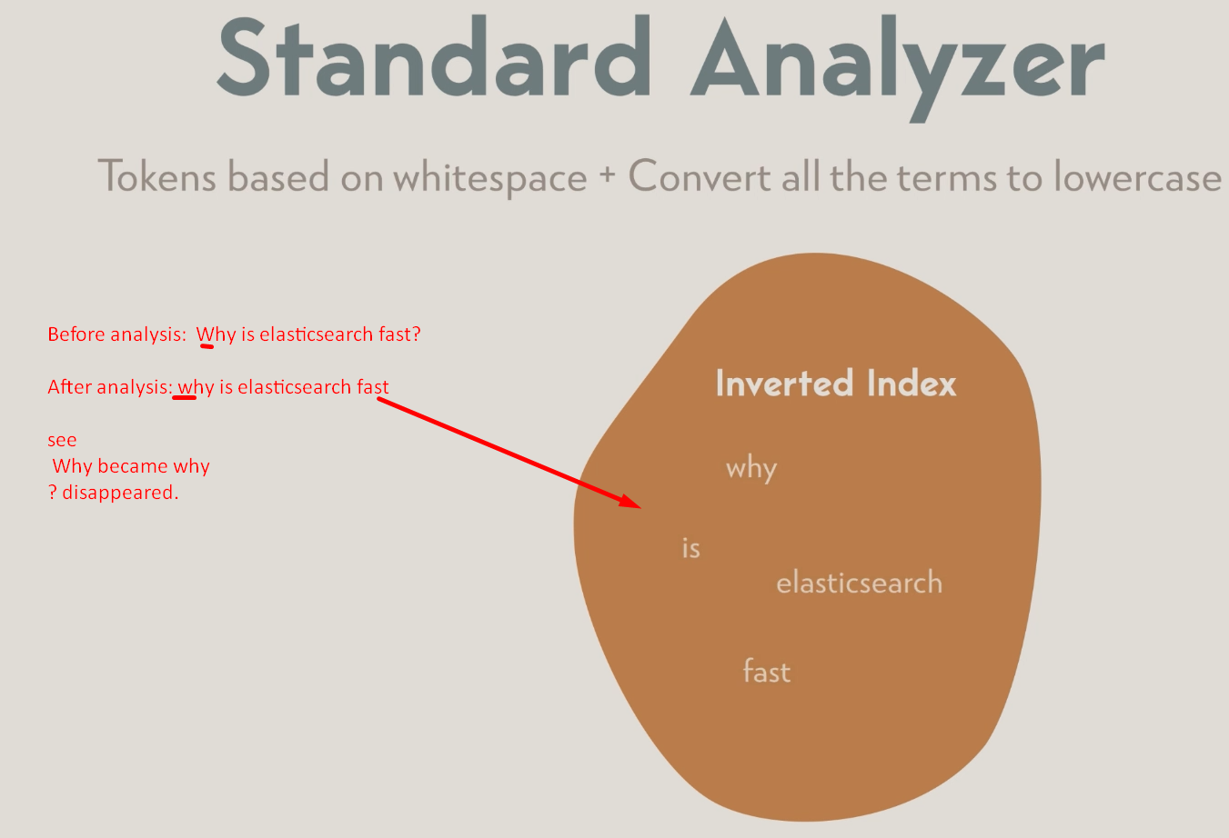
21. NOTE:
    1. The same analyzer is used in query string as that which is used in indexing a doc.
22. 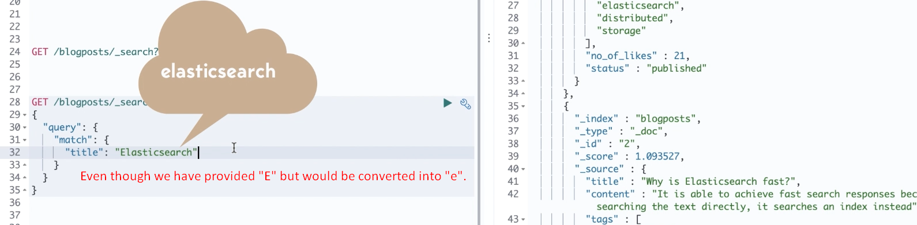

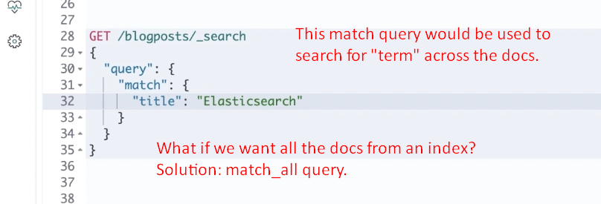  
**NOTE**: It will not match those docs marked as deleted.

1. match_all  
   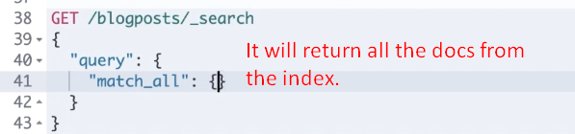

**NOTE**: It will not match those docs marked as deleted.

1. Multi-match query